# The Old Bank Hotel in Mittagong for sale after loving restoration

August 4, 2016



**One of Mittagong’s most recognisable buildings is on the market after extensive renovations over the past eight years.**

The Old Bank Hotel, now operating as boutique accommodation, [has been listed with Colliers International’s Richard Sholl and Deborah Cullen](http://www.domain.com.au/83-main-street-mittagong-nsw-2575-2012939098) on behalf of current owners Barbara Whitehouse and Warwick Wainberg

As the name suggests, the building was originally Commercial Banking Company of Sydney premises after it was built around 1893 by J.J. Campbell – at a cost of £2840.

It was in a dilapidated state when purchased in 2008, having fallen into disrepair after the bank disposed of it in the 1970s.

The building features marble mantels and fireplaces, rendered sandstock brick walls around half a metre thick, Welsh Bangor slate roof, original hardwood flooring and framing cut from local forests, hauled by bullock train to mills, and a grand entrance through double swing cedar doors to what was the business counter and staff areas of the bank.

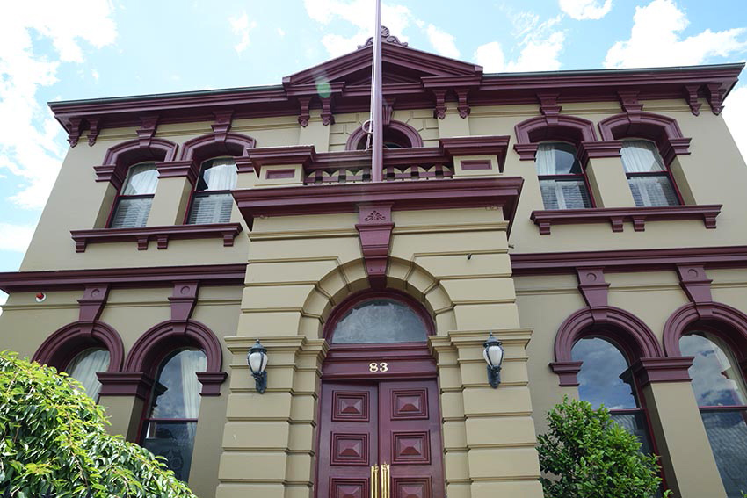The Old Bank in Mittagong is for sale through Colliers International. Photo: Supplied

Saving the building from the prospect of demolition, Ms Whitehouse and Mr Wainberg began the long task of converting the building into six individually decorated suites, as well as two separate self-contained cottages.

This meant gutting and refurbishing the existing building and installing features such as underfloor heating and a commercial kitchen.

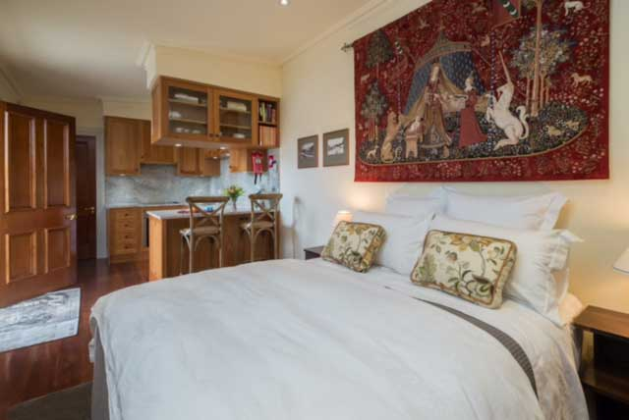One of the renovated accommodation suites inside The Old Bank Hotel. Photo: Supplied

The strongroom next to what was once the clerk’s desk with foundations two metres deep and a door cast in London in 1857 and weighing one tonne now acts as a wine cellar.

With the owners now deciding to move on, the Old Bank would suit a variety of future uses in its refurbished state, Mr Sholl said.

“The Old Bank Mittagong was purchased and lovingly restored by our clients because they understood the significance of the building to the area and wanted to ensure its longevity,” he said.

“It is an icon that locals know and one that passers-by find themselves drawn to. It has a historic past but an even greater future, the next custodians have an opportunity to create something really special be it as a restaurant, boutique accommodation, family residence or corporate headquarters.”

The Old Bank is for sale by expressions of interest, closing on Thursday, September 1, 2016.