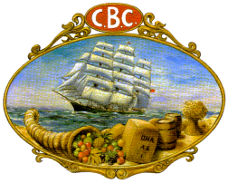

 OFFICERS CLUB Incorporated
(Incorporated under the Associations Incorporation Act 1984)
connecting former Officers of
Find us at www.CBCbank.com.au
Postal address: PO Box 319, St Ives 2075

THE NEXT CBC OUT OF SYDNEY LUNCHEON
Dear Member 25th June 2026
We wish to advise that arrangements have been confirmed for our next Out of Sydney Luncheon to be held at the Best Western Sanctuary Inn at Tamworth NSW on Saturday 17th October 2026 in their dining/restaurant area.
Address of the venue is 293 Marius Street Tamworth and timing for the luncheon is from 11.30 am till 3.30pm. We can guarantee a great event as has been the case with the many Out of Sydney Luncheons we have arranged in the past.

The cost is $60 per head for main and dessert, plus tea and coffee. Members are responsible for their own drinks/refreshments and the room will have its own bar facilities and there will be plenty of room to move about the restaurant.

This is an initial advice so that we may have an indication of your interest level and you can mark your diary accordingly. We need to provide the venue with final numbers a week before the function. Bookings for the luncheon should be made through Margaret Powell our Treasurer in the usual way.

Although we are not recommending the Motel, there are 60 rooms of accommodation at the site, and we are being offered 10% discount on mentioning you are a Member of the CBC Officers Club. The Motel can be contacted 1800 026 370 - 02 6766 2903 to book any accommodation.

There will be updates that will issue during coming months but we are very interested to get a preliminary level of interest from CBC Members.
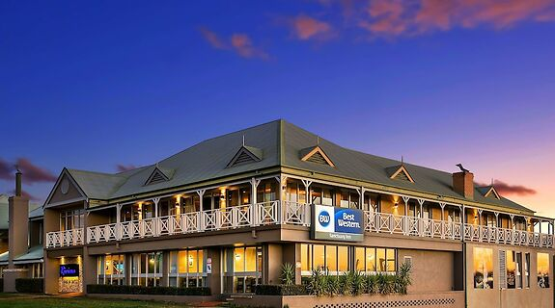
David Wyndham
President

.
Find us at www.CBCbank.com.au
Postal address: PO Box 319, St Ives 2075

