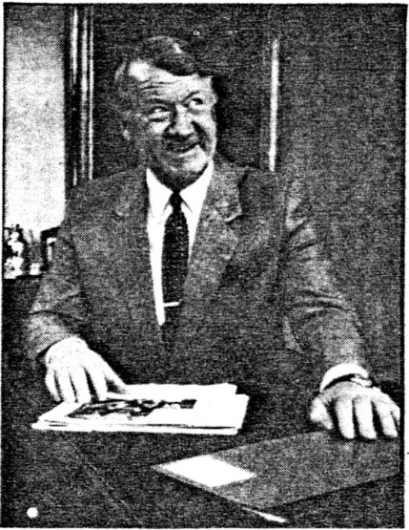No jazz bands will trumpet the launch of the new National Australia Bank on January 1. The quiet, personalised style that has characterised the National Bank for decades, and the inventive lively pace of the CBC during the past five years, will be melded together for the new bank's public image. String ensembles would be more fitting at the openings.
But the official launch will be deceptively low-key, because the National Australia Bank will fundamentally change banking in Australia.
Nobby Clark, general manager (retail banking), has plans which will transform form Australian retail banking. Retail business is the linchpin of Australia banks — the cash collector around which corporate and international banking orbit.
Clark says retail business generates about 85 percent of the merged bank, group's profit. But he says the escalate ting cost of a retail network, com pounded by a fast fall in interest rates, has forced the bank to ask whether it could afford a network in its present form, and whether people could afford to pay for the service. "The answer is multi-faceted," Clark says. "But what' we do in retail tomorrow will be distinctly different than yesterday."
The merger has enhanced the opportunities to change retail banking. There are 275 locations where the National and CBC have branches close to each other, so obviously the new bank has room for rationalisation. But Clark says: "If we just address this as a merging issue, in a post-Campbell environment we'll be dead. The opportunity is in 1308 branches."
Clark doesn't want to be locked into a traditional "bricks and mortar" network, because of the style of banking it represents and the money it ties up. The new retail network will be a tiered operation with automatic telling machines, kiosk banking using many machines and few people, one-stop banking with limited services, and full-service branches offering all of the bank's 130-odd products.
The kiosk concept represents a radical change. Clark envisages a small floor area with through the-wall machines that dispense cash and other self-service units that do account transfers or balances. There may be a customer terminal or a telephone to make inquiries, plus a few lounge chairs or pot plants. Extended banking hours, including Saturday mornings, would be desirable.
The new bank has yet to fine-tune the kiosk-banking concept but will introduce it gradually over the next few years.
One-stop branches will offer intensive customer contact but limited services. Clark says: "Whereas you go to a branch at the moment and there are 10 people behind the counter and as soon as you walk in six of them put their heads down — they are those mythical back-office people — what we want to do is if you see a person they will serve you." A handful of one-stop National Bank branches have been operating for a few years. Clark plans to open up to 20 more in the next year.
Clark hopes to centralise many back-office people. This has been tested in the ACT where the National's Kingston branch processes for all its Canberra branches.
Clark says the change in the type of retail banks will not affect the spread of retail-banking facilities. "I see at least the same number of outlets in five years' time."
Clark sees the maintaining and strengthening of customer relations as litany important. This is a difficult balancing game, because machines now play a big role in retail banking. "I think :he best message we can give to National Australia Bank customers is that we've always been customer-orientated in our outlook, dedicated to proving a reasonable level of service. We are just is dedicated now. The new bank will be everything that the customers expect of it."
The new bank wants its style to be determined by its customers. "In the past it's often been the case that banks developed a product and hoped the customer would pick it up and use it," Clark says. says the biggest customer base provided by the merger will make it possible to increase the number of products Ind services.
The new bank is determined to intensify its marketing efforts. "There are things we've seen in the CBC retail side that we like," Clark says. "They have had a fairly aggressive marketing approach."
In the corporate area, Bill Hodgson, General manager (corporate banking), also says the bank will adopt a more aggressive style. "In the past we had so many services available that no one sat down and identified them and worked out what type of services were good for customers and how they could be promoted."
Corporate finance managers will be responsible for about 25 corporate accounts each. Hodgson expects the account managers to go out into the marketplace and tell clients what corporate services are available. "It's surprising how many clients aren't advised," he says. For the first time the account managers will be profit-accountable which should hone their performance, he says.
Hodgson says the structure of the bank demonstrates its intention to be a very market-orientated organisation. "We've split ourselves up into units so that people are positively identified as being responsible," he says.
Hodgson identifies the major sources of bank corporate income, in order of importance, as corporate lending and international accounts, corporate projects and syndicated finance, and down the-line leasing and investment services.
Nobby Clark:
Strengthening customer relations
is vitally important
'the new bank will put particular emphasis on international accounts, Hodgson says. In project finance, the finance industry holds new interest for the bank. Rather than seeing this as supporting their competitors, he says: "If you're a wholesaler you could always make a margin over it." The new bank also has a specialist mining manager attached to project finance, an innovation from the National's past.
Corporate advisory services is a new division, indicating the bank's intention to compete with merchant banks in this area. "We will be concentrating our efforts more in the acquisitions area," Hodgson says. "Takeovers and mergers tend to conflict with our operations."
A lack of specialists in corporate banking has often been seen as a handicap to banks trying to make big headway against merchant banks in some corporate services. Hodgson says the National started a crash program for staff in specialist areas of corporate banking last year. Despite the high number of CBC corporate banking specialists who have left the bank, Hodgson believes the new bank has sufficient expertise to meet the competition. Bur he says that because of lower pay scales, banks will always be vulnerable to poachers of specialist staff.
In the international area chief executive Jack Booth hopes that the contribution to group revenue from international operations will rise from the present level of about 10 percent to 15 to 20 percent in the next five years. The bank sees⁻ North America as the major growth area, with Asia also contributing.
Booth wants to open a new bank office in San Francisco soon in addition to the office already in 'Los Angeles. He also sees potential in southern American states. And the CBC has an office in south Korea which Booth hopes to develop further.
Booth says Australian banks tend to copy each other's international operations and end up offering much the same services. He says the National Australia Bank's biggest new service will be the Swift system for international transfer of funds, to be introduced shortly. Service will be the key difference between the new bank and its competitors, Booth says.
In group funds management, the new bank has been structured like a central treasury, overseeing the allocating of funds domestically and internationally Booth says: "In the past, each area tended to raise their own funds and there was a tendency to invest funds — whether it be in loans or the money market in slightly haphazard ways."
Funds management, previously an administrative area in the National, had been turned into a profit centre and its operations will be more sophisticated. Each division will have to compete for its funds and central treasury will be requiring the best return on funds used, Booth says.
ALIU CROMIE

