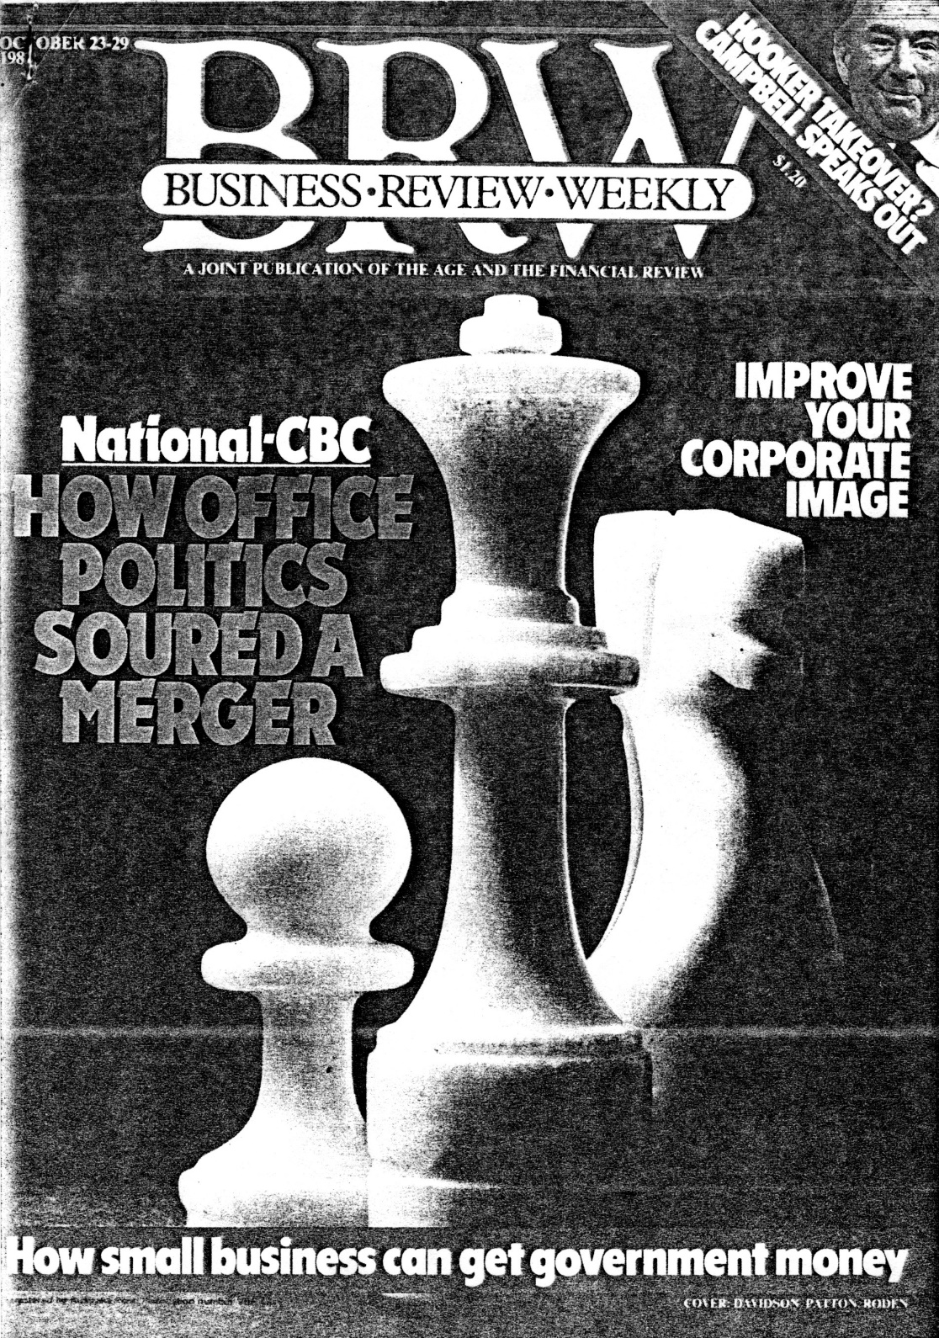

Those likely to be involved in mergers should study the traps exposed by the National-CBC marriage
veryone said it was a model merger. The National Bank had coveted the Commercial Banking Company of Sydney for decades because of its wide NSW network, and the CBC needed an ally to ward off new competition should foreign banks expand in Australia.
But the snags that have arisen in the new National Australia Bank are a case study for all boards and executives who might be involved in mergers in the 80s. Despite meticulous pre-merger preparation, the greatest goodwill from both parties and dual decision-making after the merger, the transition has not been smooth.
The boards and the senior managers did not foresee the event that would dissipate the merger's goodwill — the final choice of computer for the inategrated operation. Nearly 10 percent of the banks' staff are involved in computer and data-processing operations and the younger executives and staff of each bank had a loyalty to their computers that older executives and directors would not have expected. Also, the National Bank was amalgamating with an entrepreneurial bank, but the fact :hat many of the CBC entrepreneurs have resigned has impoverished the final result.
Despite the problems, the National Commercial Banking Group of Australia Ltd . - to be marketed as the National Australia Bank — is shaping up as an innovative force in Australian banking and no doubt the staff problems will gradually subside. The National and CBC are capitalising on the state of flux by making fundamental changes to the face of their operations
(see ‘Prepare for Banking at a Kiosk’).
With mergers and takeovers the hallmark of Australian business in the 80s, everyone is a potential player. The National Bank and the CBC could be any two companies involved in the sort of merger that happens every year, affecting hundreds of executives and hundreds of thousands of staff. In just three of the big mergers of the moment, the National and CBC have 21,000 group staff to integrate, Westpac has 34.000, and the National Mutual and T & G Life Society have 2800.
The seeds of the National Bank and CBC merger go back to the 1920s when the joint managing directors of the National Australia Bank, Jack Booth and Vic Martin. were just toddlers. "The two banks realised it made good economic sense to merge but it didn't come about." says John Marshall, general manager (group planning and control) of the National Australia Bank,
When young Vic Martin followed his father into banking and joined the CBC Grafton branch in 1941, and Jack Booth, a country kid from Queensland, joined the National Bank some years later, the merger was still no closer. However, about the time Vic Martin and Jack Booth became the respective chief executives of the CBC and National in 1976, merger whispers were on again, with meetings between the then National chairman, Sir James Forrest, and CBC chairman Sir Robert Crichton-Brown.
CBC was in bother at the time because its finance company, CAGA, had financial problems with property. But the merger talks got nowhere and the CBC stayed on its own. In the process of leading the bank out of trouble, Vic Martin created a unique banking team. "The CAGA time of adversity really knitted staff together. During periods of adversity people either pull together or the company doesn't make it," Martin says.
The merger issue was rekindled in mid-1980. Under John Marshall, a National team reassessed its future in anticipation of a more competitive post-Campbell banking environment. "If you fight in the lightweight division and suddenly they bring into the stadium some of the heavyweights — the Bank of America, Lloyds Bank, Citibank, Chase Manhattan — how are you going to stand up and be in the same league? We wanted size," Marshall says. "We wanted to be big in NSW and the CBC was the match."
About the same time Vic Martin also had a team looking at the CBC's future after Campbell. Martin says: "I felt the CBC could be flexible enough to meet the environment of the future. It was a smaller bank, but I think it had an ability to react to change. It could pick out the markets it wanted to shoot at, the products it wanted to sell."
The CBC settled on a celibate survival strategy and its executives were enthusiastic about the prospect. But while
the executives planned, in late 1980 the chairmen of the two banks started talking mergers again. National Bank chairman Sir Robert Law-Smith says he and Crichton-Brown talked up to a dozen times. "Mergers are no precise science. We'd have a discussion, make progress, and then go away and get further work done on facts and figures," Law-Smith says.
Suddenly the game became urgent when Commercial Bank of Australia chairman Stephen Kimpton announced that talks had started between his bank and the ANZ. In the event, the Wales headedaoff the ANZ and snared the CBA, and the ANZ also started talking to the CBC.. Law-Smith says: "If we didn't merge and the CBC was snapped up by the ANZ, we would have been the little bank left out."
As the CBC did not want to merge with the ANZ and the National made an offer it couldn't refuse — worth about $350 million in shares and cash
in the words of a CBC executive, "We swallowed our pride, we negotiated a merger and at least it wasn't a takeover. The disappointment was that we were never given the opportunity to see our survival plans through."
In the early merger days Martin knitted the staff together as he had during the CAGA crisis. He made a point of getting around, allaying fears of job losses and spreading his enthusiasm about the exciting future of the new bank. Typical of the spirit of goodwill, a regional CBC manager recalls the day the neighboring National staff came to his branch for afternoon tea: "The National people sat there, we sat there. We broke the tension by showing them our computer system. We convinced them the CBC system was the best," he says.
After early merger frenzy, business at the banks returned to normal for most staff. Legal people worked through the necessary merger approvals, which resulted in the CBC becoming technically a National Bank subsidiary in October last year. Only then did a merger team start work under control of John Marshall and Ivor Reed from the National, and Dave Cowper and Dr Vern Harvey from the CBC. They directed about 40 policy committees which went through the policies and procedures of both banks. The objective was to pick the best of both banks for the new, merged group.
The involvement of about 240 National and CBC people on merger committees underlines the enormity of the task of creating a new bank. Marshall says most of the policy committees sailed through. "The travel fellows were joined together before they'd even been in troduced; the advertising and publications people got together with no problems, so did the funds management people," he says. "The only big issue was the decision that had to be made about the computer system," Marshall says.
The computer decision was the one that tested the fabric of the merger, although to outsiders it looked like office politics. The National Bank has IBM mainframe computers in capital cities, on-line to branches with IBM terminals. The CBC has Honeywell mainframes, Burroughs mini-computer concentrators in regional centres, with NCR and STC terminals in all branches.
Later installation of the CBC system meant it was using more advanced computer technology than the National with extensive data-base systems. But the National had progressively updated its 13-year-old system and, like the CBC, had a high-order system. But the systems are incompatible and the two banks agreed that a common system was essential.
Both the National and the CBC computer people thought their system was the best and, at the CBC, the belief spread throughout the company. Marshall says: "The computer systems in both banks reflected the personalities of the people running them — this was their system, their child."
The fundamental differences between the bank systems are:
- The CBC system is centralised; the National's decentralised.
- The National has a shadow-post system; CBC a real-time system.
- CBC has a customer-information file base; National treats information about each account separately.
Gus Abbott, general manager, (group management information services), says the National and the new bank made a deliberate decision to go for decentralised systems. "By handling everything at one central point you are subject to calamity."
The new bank will enhance the CBC customer-information file approach which, according to Abbott, means that customers have immediate access to information on all accounts. The new bank decision to go IBM is history. Chief executive Jack Booth says he made the final decision. "It was just a matter of cold hard statistics and costs," he says.
Converting CBC branches to IBM will cost about $5 million in mainframe, storage and terminal additions this financial year, with further terminal expenditure later. Abbott says a change to the CBC's Honeywell was not costed because probably new Honeywell mainframes would have been needed, and the cost would have been much greater. A CBC computer expert suggests the new bank is adopting a band-aid approach to systems.
The dissension within the computer merger committee over the IBM decision — despite everyone having to sign statements supporting it — spread
through the CBC, including its higher levels. A senior person involved says the computer decision showed how well the merger agreement stood up. "The whole thing was a disaster. The National Bank autocratically forced the view that the National system would be it," the senior CBC source says.
Jack Booth says: "There was never any doubt about the computer decision. It was only a matter of trying to help people overcome the dramatic change in their lives." Vic Martin says: "I genuinely believe that the decision was in the best interests of the bank." Martin plays down the importance of the computer. "It was one issue that had to
be looked at with a number of others. I don't think there was any great significance to it than that," he says.
Vic Martin is probably right about the selection of the computer system being of no great importance, especially in the context of the dozens of major policy decisions that have to be made to get the new bank on the road. Booth says: "How you could become attached to something that literally is becoming like a biro - a throwaway — I find difficult to understand."
Just before Christmas 1981, Jack Booth and Vic Martin issued a circular to staff saying the final decision on the computer had been made. It was a single page announcement that, in summary, said that the new bank would use the National system as its base and, for a period, both systems would operate independently. Progressive integration would start about December 1982. A member of the CBC's Sydney staff summed up staff feelings over the computer: "Perhaps the decisions they are making are right, but they are not explaining them."
The computer decision was a watershed. After Christmas, the senior CBC management resignations started . . . A few months later a reasonably generous staff benefits package caused ructions at CBC. Also, appointments of head office general management and subsequent state office structures have tended to be summed up in "them and us" terms ... The goodwill had gone.
The senior resignations sent shivers through CBC head office in Sydney. Over the past six months about 20 middle management people have left corporate and international banking, representing about 25 percent of head office staff in these areas. A combination of reluctance to leave Sydney and an attitude that, if they had to change, why not venture elsewhere, has proved a windfall for merchant banks, the Australian Bank and the State Bank in NSW.
The following three examples illustrate the kind of executive feelings that all merger groups must contend with:
Kerry O'Connor, chief manager (corporate banking), was the first CBC executive to leave in February. O'Connor, 44, had worked for the CBC for 25 years. Before the merger, leaving the CBC was not a priority, he says. "I felt the CRC could have survived alone in the corporate climate, although it will probably benefit from the merger in the long run." O'Connor left the CBC because he says he was offered a very good job as assistant general manager (corporate and international banking) at the State Bank. "It enabled me to avoid the unknown and stay in Sydney," he says.
Ken Windeyer, manager industrial relations, also left in February. He had followed his father into the CBC and had worked for the bank for 19 years. Wind-eyer, 38, says he did not feel threatened by the merger. Apart from the sadness associated with the old institution going out of existence, he believes the change was good for the CBC. He left the bank because he had a young family and did not want to move to Melbourne. "Anyone who wants to aspire to senior management in a specialist area has to be located in Melbourne." Windeyer is now senior manager (policy and workforce planning) at the State Bank in Sydney.
Jim Becke, chief manager (money market operations), was a rare phenomenon in banking, an outsider bought in from a merchant bank four years ago to set up the CBC's money-market business. Becke, 34, left because he believed that at the new bank his input would be from a lower level. "At the CBC I could see Vic Martin, Dave Cowper and the policy committee of the bank every day." Also, Becke felt he'd achieved most of his aims in his own job, that is, setting up a successful CBC money market operation. He, like the others, also was not enamored of moving to Melbourne. Becke has returned to merchant banking as director in charge of money market NSW for Hill Samuel Australia.
Senior resignations have not abated. Vic Martin's personal assistant, Reichard Morath, left late in July. Ron Burnstein, who was chief manager (marketing) and who had appeared on new bank management sheets as chief manager (advertising and publications) left late in September. Both say they wanted to stay in Sydney. A departure that has caused a big tremor at CBC in recent weeks is Dr Vern Harvey, who was chief manager (corporate planning), and one of the two CRC people on the umbrella merger planning team.
Many of the staff who have left the CBC have been upwardly mobile youngexecutives, quite obviously in market
demand. With them has gone a great deal of the entrepreneurial and specialist skills that Vic Martin was renowned for encouraging at the CBC. Vic Martin counters by saying: "I have no doubt that the spirit of the CBC will be brought within the new organisation."
When Vic Martin went to Melbourne last year, followed later by Dave Cowper (former CBC assistant general manager finance) and Barry Buckley (former assistant general manager personnel), staff initially saw them as CBC emissaries, but that attitude has changed, and they are now viewed more as defectors. "We haven't seen nor heard of Vic Martin since he's been in Melbourne," a CBC staff member says. Another comments: "I have the feeling our men are being overruled and that they are not getting much freedom. But of course you can't get them to admit this because, rightly, they support the new management.
About 25 CBC head office people have already gone to Melbourne and a total of 50 are expected to move by the end of the school year. As further staff leave Sydney, in addition to those who have resigned, the CBC staff left behind feel increasingly isolated.
Buckley says: "My need is in Melbourne. I suppose it would be nice to get back there (Sydney) more often, but I'm not sure my appearance would contribute anything." While Buckley concedes that the CBC middle management resignations have been "substantial", the overall CBC and National turnover rate has changed little, he says.
Like so many merger agreements, the National and CBC agreement spelt out that it would not result in any loss of jobs. However, as a former CBC middle manager says: "It was put to me that there was no longer a position available. I was among three people effectively told our services would no longer be required and it was suggested we look around. There was no question of firing." The CBC man (who does not wish to be named) found another job in Sydney. Buckley says it is not the bank's policy to ask people to leave. "It may have been indicated to one man, and in error."
Another CBC staff member in Sydney says that management has told people they either work in Melbourne or find another job. "If that's not being a victim of the redundancy caused by the merger, I don't know what is," he says.
Apart from being against merger policy, it has not been necessary to use the merger to get rid of dead wood, Buckley says. "The bank has always been able to make use of people who peak early or tail off early in life," he says.
Slotting people into jobs is one of the massive tasks of the merger. Martin says: "We looked at who was the best man for the job and we stuck religiously to that." The nine general manager jobs fell into place surprisingly easily, with the top three going to National people. National's Nobby Clark, 53, who is the new general manager (retail banking), had a strong edge on his CBC counterpart, Peter Martin, who was fairly new in the retail area. Martin ended up general manager (related financial services). Bill Hodgson, 53, who is head of the new bank's corporate area, also came in well ahead of his CBC counterpart. Kevin Meyer. who was also fairly new to his job. Meyer is Jack Booth:
running retail banking in NSW. The National's Jim Ambridge. 56. did well to emerge head of international banking, but again, his choice was undisputed against the CBC's Geoff McIntyre, who is to run international banking in NSW.
The CBC rising star, Dave Cowper. 51, made the big time as general manager (group administration), an important post, but one that puts him some distance from the managing director's job for which he was in line when Vic Martin retired from the CBC. Both Booth and Martin are 59, and say they plan to stay on until the compulsory retiring age of 62. Nobby Clark leads the field on the succession.
Working the jobs down from the top level proved a lengthy task. It appears that when a National man is in a general manager's position, the other senior jobs in his department fall to National people. For example, in the head office corporate area, CBC people hold only about half a dozen of nearly 40 management jobs. This is partly because so few CBC management people were available following the resignations in Sydney.
State administrations have been finalised only in recent weeks. But there is still a big job ahead placing the hundreds of people who have to be redeployed. The precise figure of surplus staff is uncertain but Barry Buckley estimates there could be about 300 in the CBC Sydney head office, plus about 70 National people.
Jack Booth
“There are people who say they've hardly been told anything"
At branch management level, John and Bruce Rawling, both CBC branch managers until recently, are among about half a dozen branch managers who have acquired newsagencies lately. John Rawling, 32 years with the CBC, says the merger, plus financial considerations, led to his departure.
CBC people believe the merger has triggered a flood of bank manager resignations. Buckley disputes this, saying 21 CBC branch managers have resigned in the past 12 months, compared with 23 the previous year, 17 in 79-80 and 14 in 78' 79. "Every year there are branch managers who decide to get out and be their own boss," he says.
CBC branch managers are concerned about salary differences between the two banks. In the CBC, merit was awarded by an increase in base salary, whereas at the National, merit was rewarded by payment of a one-off bonus.
Buckley says his hardest merger task was devising a staff benefits package. "It didn't mean picking up the best of both worlds — that would have been far too expensive." CBC staff were upset about health scheme arrangements. Typical was a CBC family man who says he'll be out of pocket about $30 a month. But the new benefits package has swings and roundabouts; for example, the CBC people gain more generous long-service leave provisions. The 100 percent acceptance by CBC bank officials of transfer to the new fund shows most must believe they are better off. Staff could choose to remain with their old benefits and, in the case of a special CBC women's fund, the majority stayed with the old scheme.
The National Bank and CBC merger still has nearly 10 weeks of the transition period to run, until the two banks become officially, on January 1 next year, the National Australia Bank.
The worst of the head offices' and state administrations' trauma is prob ably over. Jack Booth believes that the people side of the merger will settle down far faster than appears likely at the moment. Branch staff will experience many years of uncertain: while the bank implements its new retail strategy. Booth says the integration ant rationalisation of networks could take about seven years, although he hopes the merger benefits will be felt in share holders' pockets sooner, perhaps within two years.
Already there are lessons in the CBC and National merger, even though it has still to run its full course. According to a CBC staff member, when CBC staff ask for explanations of actions, they're told the bank is a new ball game and they should run with it. "The trouble is, we don't know the ground rules," the staffer says.
Vic Martin says both partners should go into situations with an open mind, with the aim of developing a stronger unit out of two component parts.
Jack Booth's message should carry double weight because this is his second merger experience. It's got to be extremely carefully planned from the start so you know where you are going. A hidden trap for companies is to get so caught up in the monumental merger task that they don't guard their business. Booth doesn't believe the banks have lost out to the ANZ or the Commonwealth Bank during their merger.
Booth says: "The people side of the merger disturbs me a little." He acknowledges that communication with staff about merger developments is vital.

"It is amazing the number of advices we have sent out to staff, but there are people who say they've hardly been told anything." The banks had tried to communicate with staff through state managers, the rationale being that head office should not appear to be interfering. "We had the state managers down to Melbourne a number of times to keep them up with the merger progress. Somehow it has broken down," he says. "What we will be doing over the next three months is intensifing our communication, even to the extent of re-issuing some things. I think people tend to forget," Booth says.
Does Vic Martin think anyone will remember the CRC in 10 years’ time? "Yes, and I hope in 10 years’ time others will remember the National Bank —that's tradition, and I don't think it's good to throw tradition out with the garbage."

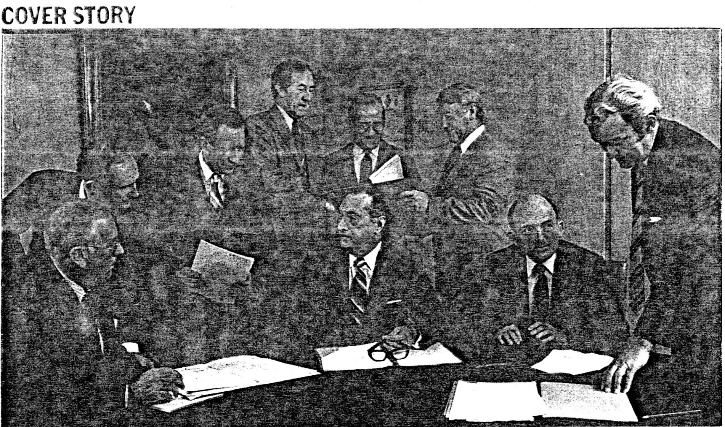
The National Australia management team:
Standing, from left: Dave Cowper (administration). Gus Abbott (information services), Clive Tavener (funds management). Jim Ambridge (international banking), Nobby Clark (retail). Bill Hodgson (corporate). Seated, from left: Barry Buckley (personnel). Jack Booth (chief executive and joint managing director), Vic Martin (joint managing director). Absent, John Marshall (planning) and Peter Martin (financial services).

